CSA1509-Cloud computing and big data analytics
Experiment-8
Create a simple cloud web application for learner counselling system using any Cloud Service Provider to demonstrate SaaS with the fields of learner name, age, address, phone, subjects studied, Year of passing, percentage of marks, domain interest, etc.
Input:
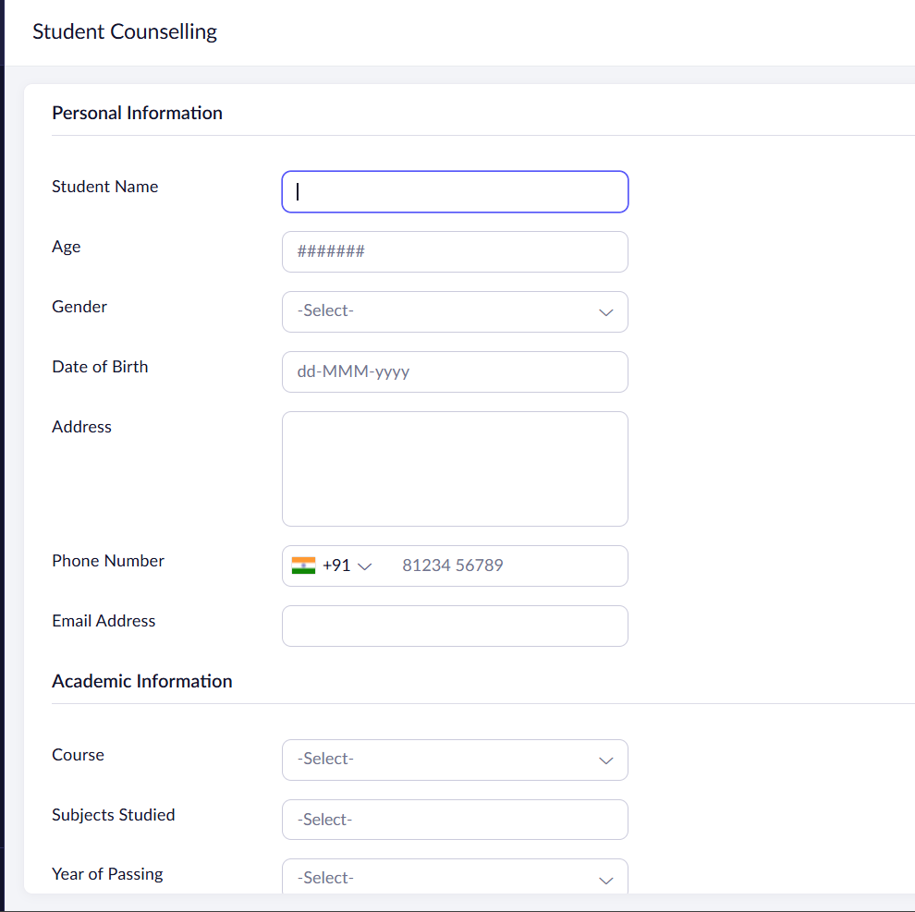
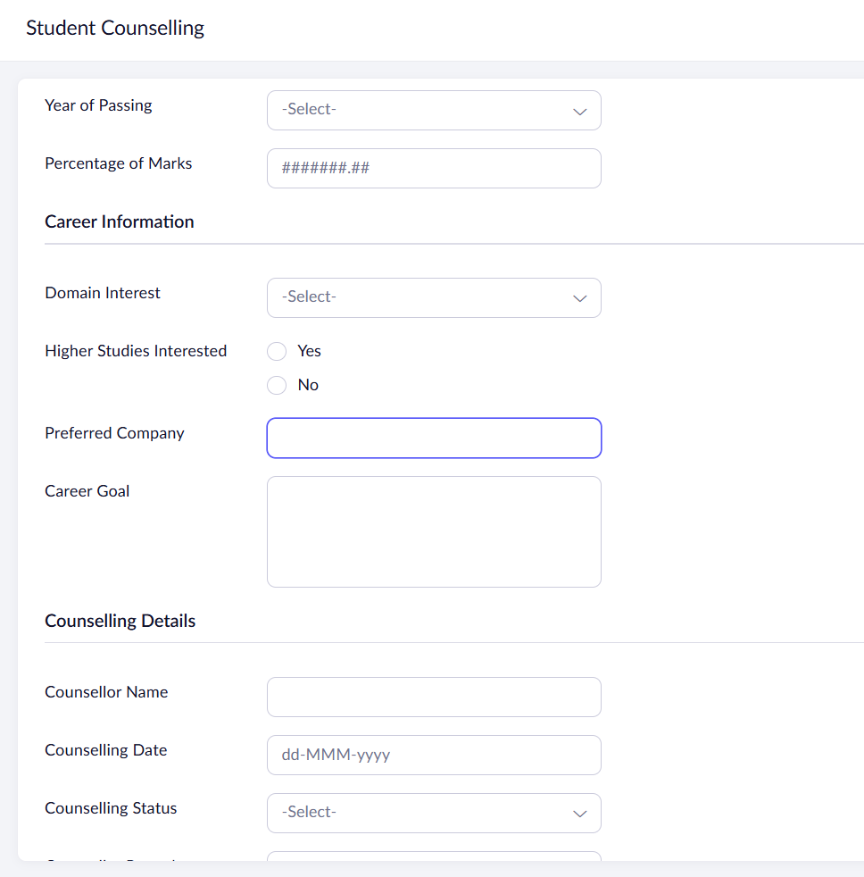

Output:
